
T itle of Manuscript (Capital Letter of Each Word)
Full Name¹*, Author Two² (All authors — full names only)
- ¹ Department of Computer Science, Faculty of Engineering, Your University, City, Country
- ² Department of …, Another University, City, Country
* Corresponding author: author.mail@institution.edu | DOI: https://doi.org/10.31181/atlasxxxxx

ARTICLE INFO | ABSTRACT
Article history  Received: 29 October XXXX  Revised: 1 December XXXX  Accepted: 9 December XXXX  Online: 10 December XXXX  Keywords  Keyword one; Keyword two; Keyword three; Keyword four (Please use semicolon as separator ;) | The abstract should present a concise overview of the study: (1) brief background, (2) problem statement, (3) research purpose, (4) methodology summary, (5) principal results, and (6) major conclusions. These six elements are compulsory. Avoid citations and non-standard abbreviations. Maximum 350 words.
1. Introduction
The first sentence of your introduction begins here [1]. Use one line of spacing after each section header. Body text is set in Calibri 12 pt, justified, with a 0.63 cm first-line indent and single line spacing.
Subsequent paragraphs follow immediately without additional spacing. For example, A nanofluid is a fluid containing nanometer-sized solid particles, typically below 100 nm, dispersed in a conventional base liquid such as water or ethylene glycol.
The final paragraph of the Introduction must explicitly identify (a) the research gap, (b) the significance of the study, and (c) the research objective. These three elements are compulsory. — End of Introduction —
📝 Section structure: 1. Introduction · 2. Methodology · 3. Results · 4. Conclusions · Acknowledgements · References. Add sub-sections as needed. See the end of the template
1.1 Sub-section Header
Sub-section body text begins here. Style: Calibri, 12 pt, Italic Bold heading, justified body.
1.1.1 Sub-sub-section header
Sub-sub-section body text. All headings at level three and below share this italic style. No spacing between consecutive headings; one blank line before the first paragraph only.

2. Methodology
Describe your research design, materials, instruments, and procedures here. Each sub-section below illustrates the style and formatting requirements for figures, tables, and equations.
2.1 Figure Style and Format
All figures must be high-resolution and clearly legible, including contour legends and axis labels. Reference every figure in the body text before it appears, e.g., as shown in Figure 1(a–b).
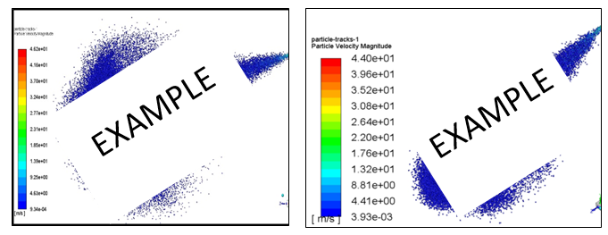
(a) (Font style: Calibri; Font size: 10) (b)
Fig. 1. Figure quality (a) Unclear and unreadable content (b) Clear and readable content (Font style: Calibri; Font size: 11; Paragraph: Align left)

📝 Figures: centre single images; place two related figures side-by-side to save space. Captions go below the figure and do not end with a full stop. Match caption width to figure width.

Fig. 1. In this case simply justify the caption so that it is as the same width as the graphic
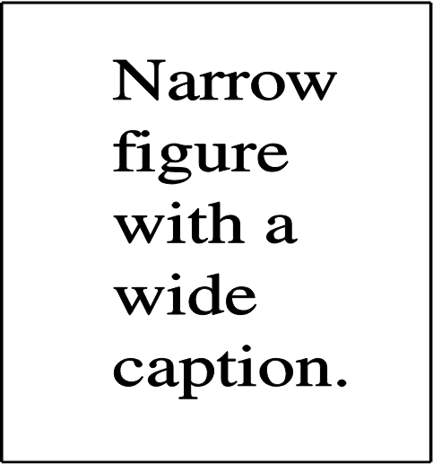
Fig. 2. These two figures have been placed side-by-side to save space |  | Fig. 3. These two figures have been placed side-by-side to save space

- Avoid excessive white space around or inside graphics.
- Size figures appropriately — neither too large nor too small.
- Place two figures side-by-side if they fit comfortably on the page.
2.2 Table Style and Format
Place tables at the centre of the page. Reference each table in the body text before it appears. Use Calibri 10 pt for table content, Calibri 11 pt for captions. Captions appear above the table and do not end with a full stop.
Table 1: Values of Reynolds number and corresponding velocity
Reynolds Number, Re | Velocity, V
1 × 10⁶ | 18 m/s
2 × 10⁶ | 36 m/s

2.3 Equation Style and Format
All equations referenced in the text are numbered sequentially, e.g., Eq. (1). Use the built-in Equation Editor (Insert → Equation). Font size: 12 pt. Equations are centred with the equation number right-aligned.
Re = ρ V x / μ (1)
where ρ is the density of air (1.18 kg/m³), V is velocity (m/s), x is characteristic length (m), and μ is dynamic viscosity (1.846 × 10⁻⁵ kg/m·s).
3. Results
Summarise the findings obtained from your experimental or numerical study. Organise results by sub-section corresponding to each research objective.
3.1 Pressure Distribution
This sub-section discusses surface pressure measurement results. Effects of angle of attack, Reynolds number, and leading-edge bluntness are each addressed in the sub-sections below.
3.1.1 Effect of Angle of Attack
Test configurations are listed in Table 1. At a Reynolds number of 2 × 10⁶, the angle of attack was limited to α = 23°. The Reynolds number was calculated from Eq. (1) and the corresponding velocities are summarised in Table 1.
4. Conclusions
The Conclusions section must directly address each research objective stated in the Introduction, summarising key findings and their significance. Example: Experimental data for the UTM-LST VFE-2 model at high angles of attack were presented. Additional experiments are required to fully characterise this complex flow topology.

Author Contributions
Conceptualization, X.X. and Y.Y.; methodology, X.X.; software, X.X.; validation, X.X., Y.Y. and Z.Z.; formal analysis, X.X.; investigation, X.X.; resources, X.X.; data curation, X.X.; writing — original draft, X.X.; writing — review & editing, X.X.; visualization, X.X.; supervision, X.X.; project administration, X.X.; funding acquisition, Y.Y. All authors have read and agreed to the published version of the manuscript.
Funding
This research was funded by [NAME OF FUNDER], grant number [XXX]. (Or: This research received no external funding.)
Data Availability Statement
Data supporting the reported results can be found at [URL / repository]. (Omit this section if no data are reported.)
Conflicts of Interest
The authors declare that they have no known competing financial interests or personal relationships that could have appeared to influence the work reported in this paper. (Or disclose any conflicts and describe the role of funders, if any.)
Acknowledgement
This research was funded by a grant from the Ministry of Higher Education (Grant No. XXXXXXX). Compulsory: if no funding, write This research was not funded by any grant.

References
📝 Style: APA. Include a DOI for every entry. Minimum 20 references. Only cite published or accepted works.

[1] Kabir, M. F., & Roy, S. (2023). Hazard perception test among young inexperienced drivers and risk analysis while driving through a T-junction. Decision Making: Applications in Management and Engineering, 6(1), 1–17. https://doi.org/10.31181/dmame181221015k
[2] Strunk, W., Jr., & White, E. B. (2000). The elements of style (4th ed.). Longman.

[3] Zizovic, M., & Pamucar, D. (2019). New model for determining criteria weights: Level Based Weight Assessment (LBWA) model. Decision Making: Applications in Management and Engineering, 2(2), 126–137. https://doi.org/10.31181/dmame1902102z

Section Structure (Research Paper) ( This is just an example to help you; you don't have to follow it exactly.)
1. Introduction
- Research context and background
- Problem statement
- Motivation and significance
- Research objectives
- Main contributions
2. Related Works (optional)
- Review of existing literature
- Comparative analysis of approaches
- Identification of limitations
- Positioning of the proposed work
- (optional: comparative summary table)
3. Methodology
- Description of the proposed approach/model
- Mathematical formulation (if applicable)
- Algorithms and techniques used (pseudo-code recommended)
- System architecture (if applicable)
- Computational complexity analysis
- (optional: justification of design choices)
4. Results
- Dataset(s) or case study description
- Experimental setup and parameter settings
- Evaluation metrics
- Quantitative results (tables, figures)
- Comparison with state-of-the-art methods
- Result analysis and interpretation
- (optional: statistical tests, ablation study)
5. Conclusions
- Summary of findings
- Scientific contributions
- Limitations of the study
- Future research directions
Acknowledgements (optional)
- Funding sources
- Institutional or individual support
- Non-author contributions
References
- Cited scientific works
- Websites
- Datasets links

